**“Money Market Operation-Treasury Banking”**

***A***

***Project Report***

*Submitted in partial fulfillment of the*

*requirements for the award of the degree of*

**BACHELOR OF TECHNOLOGY**

**in**

**COMPUTER SCIENCE & ENGINEERING**

**With specialization**

**Banking, Finance, Security and Insurance**

**by**

|  |  |
| --- | --- |
| **Name** | **Roll No.** |
| **BINEEK RAJA** | **R133201410** |
| **VIKASH ANAND** | **R133214052** |
| **VANDANA SHARMA** | **R133214051** |
| **MOHIT PANDEY** | **R133214026** |

***Under the guidance of***

**Mr. Jatin Sethi**

**Assistant Professor**

**Computer Science Department, CIT**



**Department of Computer Science & Engineering**

**Centre for Information Technology**

**University of Petroleum & Energy Studies**

**Bidholi, Via Prem Nagar, Dehradun, UK**

**October – 2016**



**CANDIDATE’S DECLARATION**

I/We hereby certify that the project work entitled **“ Money Market Operation”** in partial fulfilment of the requirements for the award of the Degree of BACHELOR OF TECHNOLOGY in COMPUTER SCIENCE AND ENGINEERING with specialization in Banking, Finance, Security and Insurance and submitted to the Department of Computer Science & Engineering at Center for Information Technology, University of Petroleum & Energy Studies, Dehradun, is an authentic record of my/ our work carried out during a period from **August**, **2016** to **November**, **2016** under the supervision of **Mr. Jatin Sethi, Assistant Proffesor, Computer Science Department.**

The matter presented in this project has not been submitted by me/ us for the award of any other degree of this or any other University.

**(BINEEK RAJA, VIKASH ANAND, VANDANA SHARMA, MOHIT PANDEY)**

**Roll No. R1332104010, R133214052, R133214051, R133214026**

This is to certify that the above statement made by the candidate is correct to the best of my knowledge.

Date: 22nd October 2016 **Jatin Sethi**

Assistant Proffesor

CIT-COES, UPES

Mr. Christalin Nelson

Program Head – B.Tech CSE-BFSI

Center for Information Technology

University of Petroleum & Energy Studies

Dehradun – 248 001 (Uttarakhand)

**ACKNOWLEDGEMENT**

We wish to express our deep gratitude to our guide **Jatin Sethi**, **Assistant Proffesor,** for all advice, encouragement and constant support that he has given us through out our project work. This work would not have been possible without his support and valuable suggestions.

We sincerely thank to our respected **Christalin Nelson**, **Program Head of the Department** for his great support in doing our project.

We are also grateful to Dr. **Manish Prateek, Associate Dean-CIT** and Dr. **Kamal Bansal, Dean CoES**, UPES for giving us the necessary facilities to carry out our project work successfully.

We would like to thank all our **friends** for their help and constructive criticism during our project work. Finally, we have no words to express our sincere gratitude to our **parents** who have shown us this world and for every support they have given us.

|  |  |  |  |  |
| --- | --- | --- | --- | --- |
| **Name** | **BINEEK RAJA** | **VIKASH ANAND** | **VANDANA SHARMA** | **MOHIT PANDEY** |
| **Roll No.** | **R133214010** | **R133214052** | **R133214051** | **R133214026** |

**ABSTRACT**

Treasury department of any organization performs several tasks. In this project we will focus on the money market operations. The calculation involves of formulas which are based on parameters calculated from a set of another formula. Thus the entire process becomes complex and time consuming. We will focus on reducing the complexity by providing an automated application which will take the inputs and calculate the results efficiently. The size of data is also very large which further makes the calculation difficult task. All the formulas are implemented manually which is very tedious task for the employees of the treasury.

When the people are working in the treasury department the results must be accurate. The application will reduce the possibility of human errors by automating the calculation involved in the money market operation of the treasury department.

Keywords: treasury, money market operations, financial mathematics, loans

**TABLE OF CONTENTS**

**S.No. Contents Page No**

1. **Introduction 6**
2. **Problem Statement 6**

1. **Objective** 7

1. Methodology 7
2. **Project Progress 8**
3. **Data Flow Diagram 9**
4. **Use Case Diagram 10**
5. **Test Case 12**
6. **Algorithms 12**

**References 16**

**Introduction:**

Treasury management includes management of an enterprise's holdings, with the ultimate goal of managing the firm's liquidity and mitigating its operational, financial and reputational risk. One of the main functions of a treasury department is to control and manage the bank's money and to make sure that all parts of the bank can readily access the cash they need for their business activities. By doing so, it makes sure that the bank remains financially secure, stable and able to function effectively to help its clients.

The Treasury of banks/financial institutions performs various functions such as portfolio management, risk management, maintaining ledger, handling cash inflow/outflow, Money market operations (Treasury Loans). Since the functions of treasury are vivid we will be focusing on its money market operations (Inter-Bank Loans) for various tenures.

The money market is where [financial instruments](http://www.investopedia.com/terms/f/financialinstrument.asp) with high liquidity and very short [maturities](http://www.investopedia.com/terms/m/maturity.asp) are traded. It is used by participants as a means for borrowing and lending in the short term, with maturities that usually range from overnight to over year or even more than that. Money market transactions are wholesale, meaning that they are for large denominations and take place between financial institutions and organizations rather than individuals. Institutions that participate in the money market include banks that lend to one another and to large organizations in the eurocurrency and time deposit markets; companies that raise money by selling [commercial paper](http://www.investopedia.com/terms/c/commercialpaper.asp) into the market, which can be bought by other organizations.

**Problem Statement:**

Money Market Operation has complex calculation with large amount of data size. As of now traditional method that is spread sheets are usually used to perform various money market operations. But to minimize the complexity and to make the whole process user friendly there is a need of an application which can perform all the operations.

**Objectives:**

1. To Study Money Market Operations
2. To implement an application using C which can perform various Money Market Operations

**Methodology:**

We are using ITRERATIVE WATERFALL MODEL due to large data size and complexity of our project.

**ITERATIVE WATERFALL MODEL**

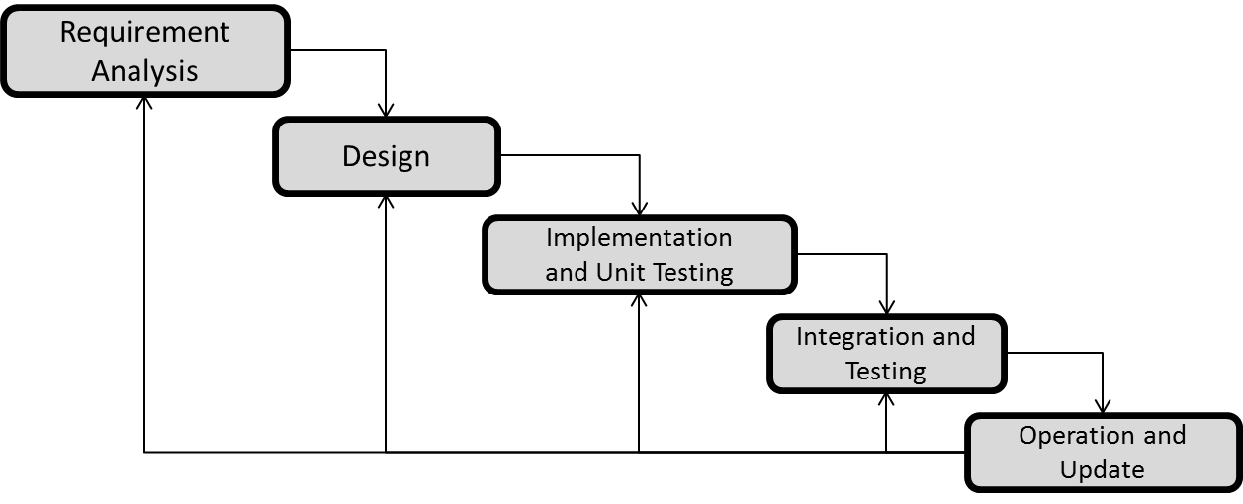

1. **Requirement Analysis:**

Data modelling i.e. collection of data which will be used as inputs and outputs.

1. **System Design:**An algorithm will be developed on the basis of formulas and data that are collected and will these data will be sampled as input in further phase. The algorithm will decrease the time complexity and will finally give an automated system for all the calculations under a single dashboard.
2. **Implementation and Unit Testing:**

We will develop the application using the algorithm developed during design phase in C language. The application will be developed in two modules and will be tested separately.

1. **Integration and Testing:**

The modules developed will be integrated to develop an application and tested by using the sample data collected during the analysis phase.

1. **Operation and Update:**

The final application developed will be deployed and updated according to the bugs which we will encounter.

**Project Progress:**



**Data Flow Diagram:**

Level - 0 DFD

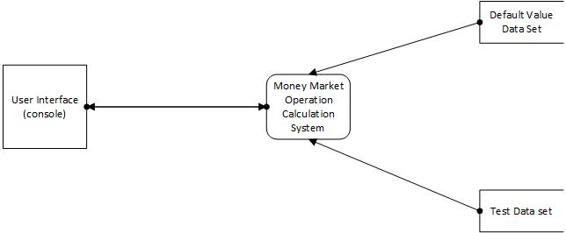

Level – 1 DFD

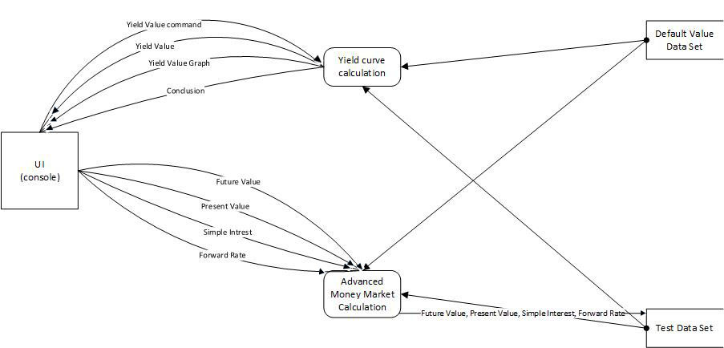

**Use Case Diagram:**

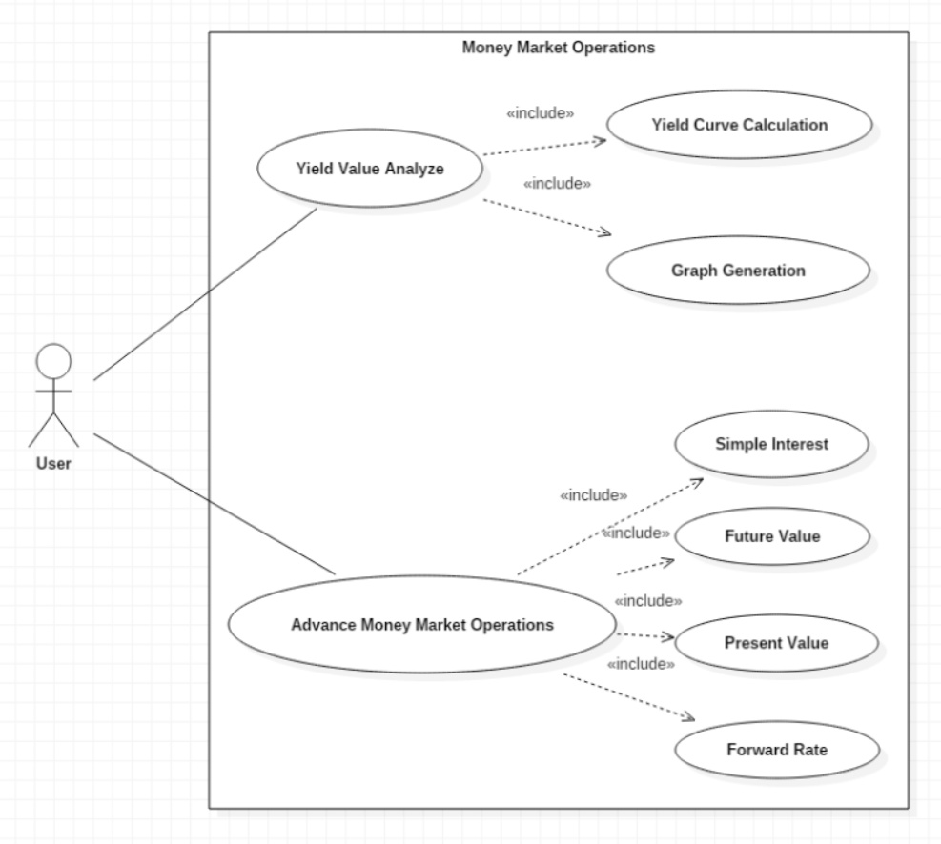

**Test Cases:**

|  |  |  |  |  |  |
| --- | --- | --- | --- | --- | --- |
| **Sample Test Cases for Treasury Banking and Money Market Operations** | | | | | |
|  |  |  |  |  |  |
| **Test Case ID** | **Test Scenario** | **Test Data** | **Expected Results** | **Actual Results** | **Pass/Fail** |
| TSI-01 | Simple Intrest | C=5000000 ,r=0.03 ,D=31 ,B=365 | Interest=12739.73 |  |  |
| TSI-02 | Simple Intrest | C=6700000 ,r=0.045 ,D=47,B=365 | Interest=38823.29 |  |  |
| TSI-03 | Simple Intrest | C=7200000 ,r=0.04 ,D=50 ,B=360 | Interest=39452.05 |  |  |
| TSI-04 | Simple Intrest | C=1250000 ,r=0.038 ,D=90 ,B=360 | Interest=11712 |  |  |
|  |  |  |  |  |  |
|  |  |  |  |  |  |
| **Test Case ID** | **Test Scenario** | **Test Data** | **Expected Results** | **Actual Results** | **Pass/Fail** |
| TFV_1-01 | Future Value (< 1Year) | PV=1000000 ,r=0.06,D=92,B=365 | Future Value= 1015123.29 |  |  |
| TFV_1-02 | Future Value (< 1Year) | PV=1250000 ,r=0.052 ,D=85 ,B=365 | Future Value= 1265136.99 |  |  |
| TFV_1-03 | Future Value (< 1Year) | PV=1200000 ,r=0.05,D=100,B=365 | Future Value= 1216438.36 |  |  |
| TFV_1-04 | Future Value (< 1Year) | PV=1080000 ,r=0.0365,D=240,B=365 | Future Value= 1105920.00 |  |  |
|  |  |  |  |  |  |
|  |  |  |  |  |  |
| **Test Case ID** | **Test Scenario** | **Test Data** | **Expected Results** | **Actual Results** | **Pass/Fail** |
| TFV_2-01 | Future Value (> 1Year) | PV=1080000 ,r=0.042,N=7 | Future Value= 1440448.87 |  |  |
| TFV_2-02 | Future Value (> 1Year) | PV=1160000 ,r=0.03,N=4 | Future Value= 1305590.22 |  |  |
| TFV_2-03 | Future Value (> 1Year) | PV=1020000 ,r=0.04,N=3 | Future Value= 1147361.28 |  |  |
| TFV_2-04 | Future Value (> 1Year) | PV=1106000 ,r=0.0365,N=2 | Future Value= 1188211.47 |  |  |
|  |  |  |  |  |  |
| **Test Case ID** | **Test Scenario** | **Test Data** | **Expected Results** | **Actual Results** | **Pass/Fail** |
| TPV_1-01 | Present Value (< 1Year) | FV=1000000 ,r=0.055,D=61,B=365 | Present Value= 990891.94 |  |  |
| TPV_1-02 | Present Value (< 1Year) | FV=1250000 ,r=0.052 ,D=85 ,B=365 | Present Value= 1235044.12 |  |  |
| TPV_1-03 | Present Value (< 1Year) | FV=1200000 ,r=0.05,D=100,B=365 | Present Value= 1183783.78 |  |  |
| TPV_1-04 | Present Value (< 1Year) | FV=1080000 ,r=0.0365,D=240,B=365 | Present Value= 1054687.50 |  |  |
|  |  |  |  |  |  |
|  |  |  |  |  |  |
| **Test Case ID** | **Test Scenario** | **Test Data** | **Expected Results** | **Actual Results** | **Pass/Fail** |
| TPV_2-01 | Present Value (> 1Year) | FV=1000000 ,r=0.055, N=2 | Present Value= 935721.33 |  |  |
| TPV_2-02 | Present Value (> 1Year) | FV=1250000 ,r=0.052 ,N=1 | Present Value= 1184834.12 |  |  |
| TPV_2-03 | Present Value (> 1Year) | FV=1200000, r=0.04 ,N=3 | Present Value= 1066795.63 |  |  |
| TPV_2-04 | Present Value (> 1Year) | FV=1080000 ,r=0.0365,N=4 | Present Value= 935721.33 |  |  |
|  |  |  |  |  |  |
| **Test Case ID** | **Test Scenario** | **Test Data** | **Expected Results** | **Actual Results** | **Pass/Fail** |
| TFR_1-01 | Forward Rates Calculation (< 1 YEAR) | r1= 7.75% (91 days), rs=7.5(183 days), Dl=183,DS=91,Dl-S=92,B=365 | FR=6.7374% |  |  |
| TFR_1-02 | Forward Rates Calculation (< 1 YEAR) | r1= 7.93% (95 days), rs=7.7(190 days), D1=190,DS=95,D1-S=95, B=365 | FR=6.7976 % |  |  |
| TFR_1-03 | Forward Rates Calculation (< 1 YEAR) | r1= 7.99% (99 days), rs=7.96(186 days), D1=186,DS=96,D1-S=90,B=365 | FR=6.6332% |  |  |
| TFR_1-04 | Forward Rates Calculation (< 1 YEAR) | r1= 7.45% (91 days), rs=7.32(185 days), D1=185,DS=91,D1-S=94,B=365 | FR=6.40664 % |  |  |
|  |  |  |  |  |  |
| **Test Case ID** | **Test Scenario** | **Test Data** | **Expected Results** | **Actual Results** | **Pass/Fail** |
| TFR_2-01 | Forward Rates Calculation (> 1 YEAR) | r1= 5.75% , rs=5.5, N=15,n=2,N-n=13 | FR=5.78882% |  |  |
| TFR_2-02 | Forward Rates Calculation (> 1 YEAR) | r1= 5.855% , rs=5.54, N=16,n=4,N-n=12 | FR=5.96141 % |  |  |
| TFR_2-03 | Forward Rates Calculation (> 1 YEAR) | r1= 5.95% , rs=5.55, N=14,n=3,N-n=11 | FR=6.06087% |  |  |
| TFR_2-04 | Forward Rates Calculation (>1 YEAR) | r1= 5.66% , rs=5.5, N=13,n=4,N-n=9 | FR=5.73164 % |  |  |

**Algorithms:**

**Calculating YIELD**

YIELD(FV,i,MV)

{

MV=FV;

roi=(i*FV)/100;

for (i=1 to MV.length)

{

roi=Effective_ROI(MV, FV);

}

}

Effective_ROI(MV,FV)

{

EROI=(MV/FV)*100;

return EROI;

}

MV: Market Value, FV: Future Value, roi: Rate of Interest, i: Amount

**Calculating Simple Interest**

INTEREST(C,r,D,B)

{

I=C*r*Effective Days(D,B)

}

Effective Days(D,B)

{

EDAYS=(D/B)

return EDAYS

}

C: Capital Amount, D: Number of Days of Interest Period, B: Days Basis of Calculation,

I: Simple Interest, r: Rate of interest

**Calculating Forward Rate( >1 year)**

FORWARD_RATE2(T1,T2)

{

FR={pow(T1,T2)}-1;

}

Term1(rl,rs,N,n)

{

T1={pow(1+rl,N)/pow(1+rs,n)};

return T1;

}

Term2(N,n)

{

T2=1/(N-n);

return T2;

}

FR: Forward Rate, rl: Long Term Interest rate, rs: Short Term Interest rate, N:Terms in Year (Long Term) n: Terms in Year (Short Term)

**Calculating Forward Rate(< 1 year)**

FORWARD_RATE1(T3,T4,T5)

{

FR={(T3/T4)-1}*T4;

}

Term3(rl,Dl,B)

{

T3={1+(rl*(Dl*B))}

return T3;

}

Term4(rs,Ds,B)

{

T4={1+(rs*(Ds/B))};

return T4;

}

Term5(B,Dl-Ds)

{

T5=B/(Dl-Ds);

return T5;

}

FR: Forward Rate, rl: Long Term Interest Rate, rs: Short Term Interest Rate,

Dl: Number of Days, Long Term Ds: Number of Days, Short Term B: Day Basis of Calculation

**Calculating Present Value(< 1 year)**

PRESENT_VALUE1(FV,T6)

{

PV=FV/T6;

}

Term1(r ,D,B)

{

T6=1+(r*(D/B));

return T6;

}

FV: Future Value, PV: Present Value: r: Interest Rate, B: Days Basis of Calculation,

D: Number of Days of Interest Period,

**Calculating Present Value(> 1 year)**

PRESENT_VALUE2(FV,T7)

{

PV=FV/T7;

}

Term7(r,N)

{

T7=pow(1+r,N);

return T7;

}

FV: Future Value, PV: Present Value, r: Rate of Interest, N: Terms in Year

**Calculating Future Value (< 1year)**

FutureValue1(PV,r,D,B)

{

FV=PV*(1+(r*(Effective_days(D,B));

return FV;

}

FV: Future Value, PV: Present Value: r: Interest Rate, B: Days Basis of Calculation,

D: Number of Days of Interest Period,

**Calculating Future Value(> 1 year)**

FutureValue2(C,T8)

{

FV=C*T8;

}

Term8(r,N)

{

T8=pow(1+r,N)

return T8;

}

FV: Future Value, r: Rate of Interest, N:Terms in Year, C: Capital Amount

**References:**

1. Jae K. Shim and Joel G. Siegel, *Financial Management*, 3rd edition.
2. Roman L. Weil, Katherine Schipper and Jennifer Francis, *Financial Accounting: An Introduction to Concepts, Methods and Uses*, 14th edition.
3. Finance Trainer, *Financial Mathematics Money Market.*